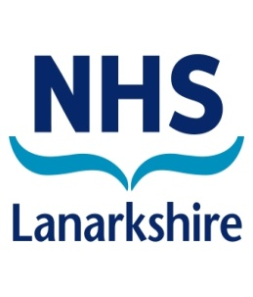

**NATIONAL SMILE MONTH**

**What is National Smile Month?**



National Smile Month is the UK’s largest oral health campaign geared at promoting good oral hygiene. Right at the heart of it you will find three key messages that can go a long way to improving oral health. These are:

* Brush your teeth for two minutes twice a day using

a fluoride toothpaste.

* Cut down on how often you have sugary food and

drinks.

* Visit the dentist regularly; as often as recommended

For more information on how to maintain good oral hygiene, visit the website at[**www.nationalsmilemonth.org**](http://www.nationalsmilemonth.org)**.**